Maths Studies Calculator Guide

- Numbers and Algebra.
Helpful Symbols:

Exponent
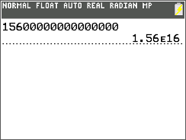
The ᴱ symbol shown indicates the operation x10 in standard form notation. The number following it would be the power that the x10 would be put to if you were writing standard form out in full. For example, if you were writing the above as standard form, it would come out as 1.56 x10^16.

Operations:

Factorization
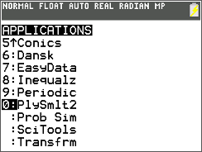
Press the ‘APPS’ button (it should be purple) and scroll down to the app called PlySmlt2, on my calculator, it is the 10th option in the list of apps.

Press ‘ENTER’ when this screen comes up.

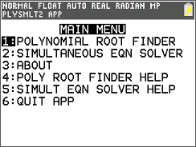
Select the polynomial root finder by pressing ‘ENTER’ when the cursor is over it.

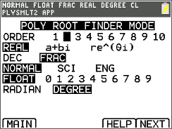
Select the power to which your first x is being multiplied by from the ORDER options. As the equation I will be working with is x^2+6x-2=0, I will have my ORDER set as 2 as my x is being squared. For the purposes of this operation, leave every other option and press the graph button to progress to the next screen.
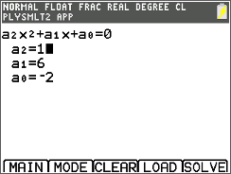
‘ENTER’ the values that would be for a2, a1 and a0. For me, these would be 1 for a2, 6 for a1 and -2 for a0 as I am multiplying my x^2 by 1, my x by 6 and my final number being added or subtracted is -2. Then press the graph button to instruct the calculator to solve the equation that you have inputted into it.

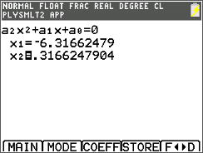
The x1 and x2 that are shown are the two values for which x can solve the equation x^2+6x-2

- Descriptive Statistics
Operations:
Entering a table of results

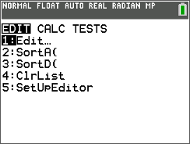
The list screen, where you can enter the results that you have obtained can be completed by pressing the ‘STAT’ button and then selecting the ‘Edit…’ option.

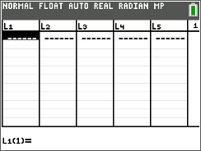
Then pressing the ‘ENTER’ button when the ‘Edit…’ option is selected will take you to the list editor. Here you will enter all of the information for the results that you are wanting to use to calculate descriptive statistics such as the interquartile range, mode, median etc.

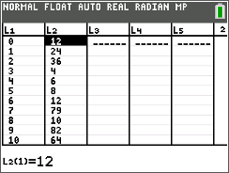
Next, you want to add the data that you are working with. In this case, the first list (represented on the calculator as ‘L1’) will give the result with the second list (represented on the calculator as ‘L2’). It is important to note that if you accidentally miss out a value when you are entering them into your table, if you place select the point where the result should be and press ‘2nd’ and then the ‘DEL’ key with the 2nd function of ‘INS’ (a.k.a. insert) the results will be moved down from the point where you need to add a value and a 0 will be placed where you need to enter your missed out information so that you can add it (this is shown below). Also, pressing the ‘ENTER’ key on a selected cell of the list will allow you to edit it using the number keypad and the ‘DEL’ key on your calculator you will have to do this to replace the 0 that is added by using the insert command outlined above.. Furthermore, just pressing the ‘DEL’ key will remove the cell entirely from that list’s results, it will not remove the entire row.
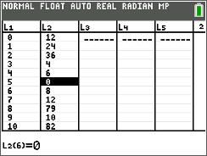
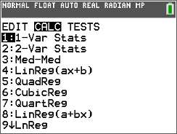
Once you have finished entering your details, you can calculate different values. This can be done by going from the list screen and pressing the ‘STAT’ key once more. Once you have done this, press the right movement key and select the ‘1-Var Stats’ option.

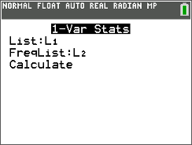
From this screen, you can select the different lists to represent what in the calculations. As our different result list was L1 we will leave the ‘List:’ option as L1. However, we must set our Frequency list as L2. To do this, scroll down to the ‘FreqList:’ option and press the ‘2ND’ button on your calculator and press the ‘2’ key (the ‘2’ key has the second function of inputting the ‘L2’ symbol.

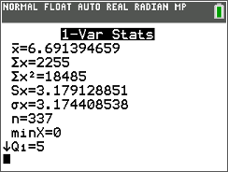
Once you have set ‘L2’ as the frequency list, you should then move down to the ‘CALCULATE’ option, select it and then press enter. Wait a moment and the different calculated results should show up on your screen, much like in the image above.

- Graphing On Your Calculator
Graphing a simple equation

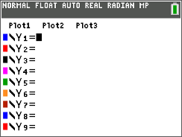
The first thing that you want to do is press the ‘Y=’ button on your calculator which will take you to this screen where you can enter the quadratic equation that you are wanting to solve.

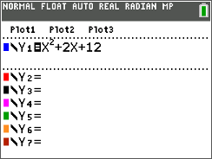
You then want to enter the equation that you wish to solve into the ‘\Y1’ space. You can see a colour to the left of the ‘\Y1’ this will be the colour that your graph will be drawn in. The different spaces on the equation entering screen (‘\Y2’, ‘\Y3’, ‘\Y4’ etc.) are for other equations that you might want to draw in tandem with each other, all equations that you want to graph can be entered from this screen. The equation that I will be working with at first is X^2 + 2X +12.

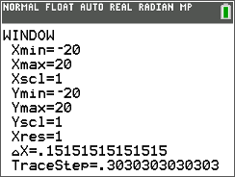
Next, you want to press the ‘WINDOW’ button on your calculator. This screen will allow you to edit the different area that you are viewing of your graph. Furthermore, you are able to edit the scale of each axis on your graph. Furthermore, usually maximum and minimum values of 20 and -20 for the X and Y axis are a good starting point leaving the scale for each axis of your graphs being 1.

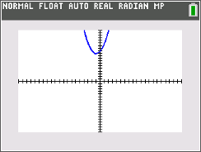
Next, you want to press the ‘GRAPH’ button on your calculator. This will allow the calculator to graph your equation. Note that if it doesn’t show up, you might have to mess with the window values to make it visible.

Solving for certain Y values

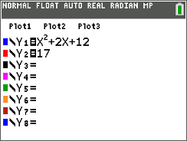
First you want to enter the equation that you are wanting to solve for when Y equals a certain value. I will be using the equation Y = X^2 + 2X + 12. However, in the section below you want to simply put the value that you have been told to solve the equation when Y equals it. For example, if I had been told to solve the equation for when Y=17 I would put 17 (this is what I will be working with).

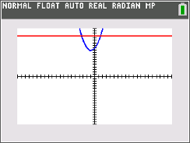
Once you have done this, you will press the ‘GRAPH’ button to bring up the two equations.

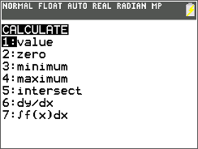
The next thing that you want to do is press the ‘2^{ND’} button on your calculator and then press the ‘TRACE’ button. This will open up the ‘CALC’ Menu screen. Scroll down to the ‘intersect’ option and press enter.

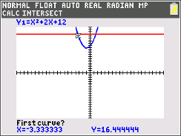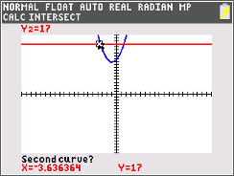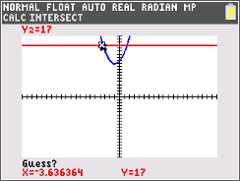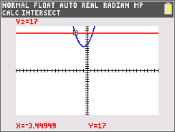
Select the blue line as the first curve as close to one of the red line’s intersections and press enter. Then repeat this but on the red line, close to the same point of intersection as you did for the blue line and press enter, when the calculator then says “Guess?” press enter. You should now see the calculated intersection point. Repeat this for each intersection and you will have the calculated values of X for your given Y value.

It should be noted that these instructions can be reused to calculate any intersection point between two graphs

Calculating Maximum or Minimum Point

The first thing that you are wanting to do is press the ‘Y=’ button, this will then bring up the ‘Y=’ screen shown above. You then want to enter the quadratic equation that you are wishing to find the minimum or maximum point of.

Next, you want to press the ‘GRAPH’ button. After this you will be taken to the screen shown above.

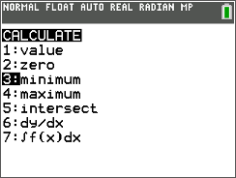
Next, you want to press the ‘2ND’ button and then press the ‘TRACE’ button (which has the 2nd function of ‘CALC’). This will then bring up the calculation screen, shown above. You then want to go down to the maximum or minimum option (depending on whether or not you are wanting to calculate a maximum or a minimum point). In this case, I have a positive quadratic graph so I will be calculating a minimum point.

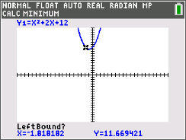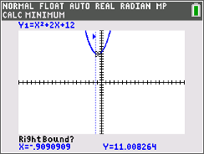
Then, select a left bound point as close to the bottom of (or top if you are calculating a maximum point) as possible and then press ‘ENTER’, as shown above you will then be asked to pick a right bound point in a similar way to how you found the left bound point. The right bound point should be as close to the bottom of the graph as possible (or top if you are calculating a maximum point).

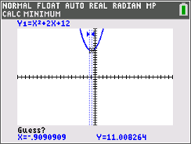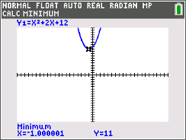
Then, when the ‘Guess?’ message comes up, you should then press the ‘ENTER’ button. This will then cause the calculator to display its calculated maximum or minimum point. As shown above.

Calculating a specific x value

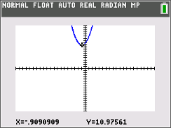
Press the “GRAPH” button to bring up your graphed equation (if you have no graphed equation follow the instructions on graphing an equation given in the tutorial of calculating a maximum or minimum point of a graph).

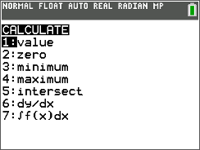
Press the ‘2ND’ button and then the ‘TRACE’ button (which has the 2ND function of ‘CALC’), this will bring up the calculate screen.

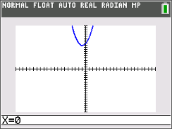
Press the ‘ENTER’ button when you have the ‘VALUE’ option selected. This will bring up the screen above, where you should enter the x value that you are trying to solve the quadratic for in front of the ‘X=’. As you can see, I have entered the x value that I am attempting to solve for as zero.

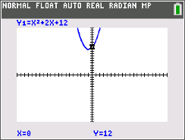
Press the ‘ENTER’ button once you have entered the value that you are trying to solve for and it should show the y value for the x value that you have given on your graph, the specific coordinates will be shown at the bottom of the screen and the plotted point will be highlighted by a flashing cross on the point(s) with the x value that you have entered into the calculator.

